Mental Arithmetic
# Source: AI Source: Provided by: [Data Path: Persons Table -> ID Column: 1, Name_En Column: Motasem Essam] -> From: [ChatGPT] on [7/15/2026]
Mental Arithmetic is the process of performing mathematical calculations entirely in the mind without using paper, calculators, or other computational tools. It emphasizes speed, accuracy, logical thinking, and efficient calculation strategies.
Mental arithmetic is one of the fundamental skills in arithmetic and forms the basis for success in algebra, geometry, statistics, finance, engineering, computer science, and everyday problem-solving.

Definition
# Source: AI Source: Provided by: [Data Path: Persons Table -> ID Column: 1, Name_En Column: Motasem Essam] -> From: [ChatGPT] on [7/15/2026]
Mental Arithmetic is the ability to perform calculations mentally by applying mathematical knowledge, number sense, and efficient strategies.
Unlike written arithmetic, mental arithmetic relies on:
- Number relationships
- Place value
- Estimation
- Patterns
- Arithmetic properties

Purpose of Mental Arithmetic
# Source: AI Source: Provided by: [Data Path: Persons Table -> ID Column: 1, Name_En Column: Motasem Essam] -> From: [ChatGPT] on [7/15/2026]
Mental arithmetic helps to:
- Improve calculation speed
- Increase numerical accuracy
- Develop number sense
- Strengthen logical thinking
- Reduce dependence on calculators
- Build confidence in mathematics

Basic Mental Arithmetic Operations
# Source: AI Source: Provided by: [Data Path: Persons Table -> ID Column: 1, Name_En Column: Motasem Essam] -> From: [ChatGPT] on [7/15/2026]
Mental arithmetic includes all fundamental arithmetic operations:
- Addition
- Subtraction
- Multiplication
- Division
- Exponents
- Roots
- Fractions
- Decimals
- Percentages
- Estimation

Mental Addition Strategies
# Source: AI Source: Provided by: [Data Path: Persons Table -> ID Column: 1, Name_En Column: Motasem Essam] -> From: [ChatGPT] on [7/15/2026]
1. Break Apart Numbers
Example:
$$48+36$$
Break apart:
$$48+30+6 \\ 78+6=84$$

2. Make Tens
Example:
$$29+17$$
Move
$$1$$
from
$$17$$
to
$$29 \\ 30+16=46$$

3. Compensation
Example:
$$198+37$$
Think
$$200+37=237$$
Subtract
$$2 \\ 237-2=235$$

Mental Subtraction Strategies
# Source: AI Source: Provided by: [Data Path: Persons Table -> ID Column: 1, Name_En Column: Motasem Essam] -> From: [ChatGPT] on [7/15/2026]
1. Count Up
Example:
$$500-497$$
Count:
$$497→500$$
Answer:
$$3$$

2. Compensation
Example:
$$302-98$$
Think:
$$302-100=202$$
Add back
$$2$$
Answer:
$$204$$

3. Break Apart
Example:
$$83-27$$
Subtract
$$20$$
then
$$7 \\ 83-20=63 \\ 63-7=56$$

Mental Multiplication Strategies
# Source: AI Source: Provided by: [Data Path: Persons Table -> ID Column: 1, Name_En Column: Motasem Essam] -> From: [ChatGPT] on [7/15/2026]
1. Distributive Property
Example:
$$23×5 \\ (20+3)×5 \\ 100+15=115$$

2. Multiplying by 10
Example:
$$47×10=470$$

3. Multiplying by 9
Example:
$$24×9=24×10-24=240-24=216$$

4. Doubling and Halving
Example:
$$25×16$$
Double
25
Half
16
$$50×8 \\ 100×4 \\ 400$$

Mental Division Strategies
# Source: AI Source: Provided by: [Data Path: Persons Table -> ID Column: 1, Name_En Column: Motasem Essam] -> From: [ChatGPT] on [7/15/2026]
1. Use Multiplication Facts
Example:
$$72÷8=9$$

2. Divide in Parts
Example:
$$180÷6 \\ 120÷6=20 \\ 60÷6=10$$
Total:
$$30$$

3. Factor the Divisor
Example:
$$96÷12$$
Divide by
4
then by
3
$$96÷4=24 \\ 24÷3=8$$

Mental Percentage Strategies
# Source: AI Source: Provided by: [Data Path: Persons Table -> ID Column: 1, Name_En Column: Motasem Essam] -> From: [ChatGPT] on [7/15/2026]
10%
Move decimal one place left.
Example:
10% of
250
=
25

5%
Half of 10%.
Example:
5% of
200
=
10

1%
Move decimal two places.
Example:
1% of
700
=
7

25%
Divide by

Example:
25% of
80
=
20

50%
Half.
Example:
50% of
180
=
90

Mental Fraction Strategies
# Source: AI Source: Provided by: [Data Path: Persons Table -> ID Column: 1, Name_En Column: Motasem Essam] -> From: [ChatGPT] on [7/15/2026]
Half
$$\frac{1}{2}$$
Divide by

Quarter
$$\frac{1}{4}$$
Divide by

Three Quarters
Multiply by
3
then divide by

Example:
$$\frac{3}{4}×80=60$$

Mental Decimal Strategies
# Source: AI Source: Provided by: [Data Path: Persons Table -> ID Column: 1, Name_En Column: Motasem Essam] -> From: [ChatGPT] on [7/15/2026]
Example
$$2.5×4$$
Think
$$25×4=100$$
Move decimal back
$$10$$

Mental Square Strategies
# Source: AI Source: Provided by: [Data Path: Persons Table -> ID Column: 1, Name_En Column: Motasem Essam] -> From: [ChatGPT] on [7/15/2026]
Know common squares.
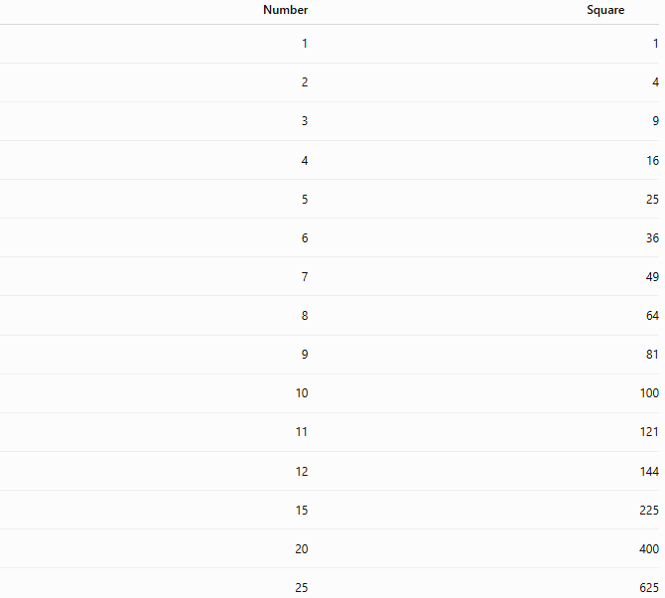
Number | Square
1 | 1
2 | 4
3 | 9
4 | 16
5 | 25
6 | 36
7 | 49
8 | 64
9 | 81
10 | 100
11 | 121
12 | 144
15 | 225
20 | 400
25 | 625

Mental Cube Strategies
# Source: AI Source: Provided by: [Data Path: Persons Table -> ID Column: 1, Name_En Column: Motasem Essam] -> From: [ChatGPT] on [7/15/2026]
Know common cubes.
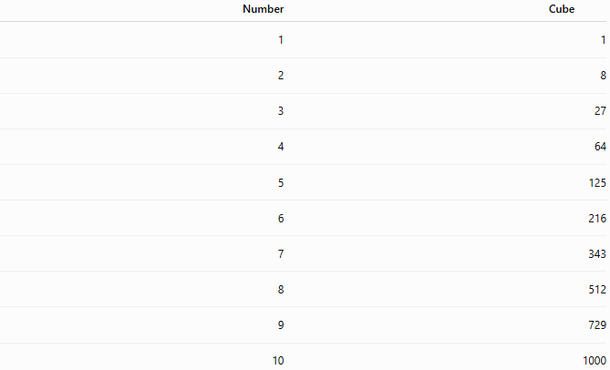
Number | Cube
1 | 1
2 | 8
3 | 27
4 | 64
5 | 125
6 | 216
7 | 343
8 | 512
9 | 729
10 | 1000

Estimation
# Source: AI Source: Provided by: [Data Path: Persons Table -> ID Column: 1, Name_En Column: Motasem Essam] -> From: [ChatGPT] on [7/15/2026]
Round numbers before calculating.
Example:
$$198+304$$
Estimate:
$$200+300=500$$
Exact:
$$502$$

Applications
# Source: AI Source: Provided by: [Data Path: Persons Table -> ID Column: 1, Name_En Column: Motasem Essam] -> From: [ChatGPT] on [7/15/2026]
Mental arithmetic is used in:
- Arithmetic
- Algebra
- Geometry
- Statistics
- Finance
- Engineering
- Computer Science
- Economics
- Shopping
- Everyday calculations

Relationship to Other Topics
Mental arithmetic supports:
- Number Sense
- Place Value
- Estimation
- Arithmetic Operations
- Fractions
- Decimals
- Percentages
- Ratios
- Proportions
- Algebra

Real-Life Applications
# Source: AI Source: Provided by: [Data Path: Persons Table -> ID Column: 1, Name_En Column: Motasem Essam] -> From: [ChatGPT] on [7/15/2026]
Mental arithmetic is useful for:
- Shopping discounts
- Restaurant bills
- Currency exchange
- Budget planning
- Banking
- Measurements
- Travel calculations
- Cooking
- Sports statistics
- Quick decision-making

Real-Life Examples
# Source: AI Source: Provided by: [Data Path: Persons Table -> ID Column: 1, Name_En Column: Motasem Essam] -> From: [ChatGPT] on [7/15/2026]
1. Shopping
Price:
$$\$18$$
Discount:
10%
Mentally:
$$18-1.8=16.2$$

2. Restaurant
Bill:
$$\$48$$
Tip:
20%
$$10\%=4.8$$
Double:
$$9.6$$

3. Travel
Speed:
60 km/h
Time:
3 hours
Distance:
$$180$$
km

4. Grocery Store
4 apples cost
$12.
Each apple:
$$\$3$$

5. Fuel
30 liters for 500 km
Fuel for 100 km:
$$6$$
liters

6. Banking
Interest:
5%
On
$400
Interest:
$$20$$

Tips for Improving Mental Arithmetic
# Source: AI Source: Provided by: [Data Path: Persons Table -> ID Column: 1, Name_En Column: Motasem Essam] -> From: [ChatGPT] on [7/15/2026]
- Memorize addition and multiplication tables.
- Learn common fractions, squares, and cubes.
- Practice estimation.
- Break large numbers into smaller parts.
- Use compensation and rounding.
- Practice daily with short exercises.

Common Mistakes
# Source: AI Source: Provided by: [Data Path: Persons Table -> ID Column: 1, Name_En Column: Motasem Essam] -> From: [ChatGPT] on [7/15/2026]
- Ignoring place value.
- Forgetting decimal placement.
- Rounding too early.
- Performing operations in the wrong order.
- Relying only on memorization instead of understanding strategies.

Key Points
# Source: AI Source: Provided by: [Data Path: Persons Table -> ID Column: 1, Name_En Column: Motasem Essam] -> From: [ChatGPT] on [7/15/2026]
- Mental arithmetic is calculation without external tools.
- It emphasizes speed, accuracy, and logical thinking.
- Efficient strategies are more important than memorizing every answer.
- Strong number sense improves mental calculation.
- Regular practice significantly increases speed and confidence.

Mental Arithmetic vs. Written Arithmetic
# Source: AI Source: Provided by: [Data Path: Persons Table -> ID Column: 1, Name_En Column: Motasem Essam] -> From: [ChatGPT] on [7/15/2026]
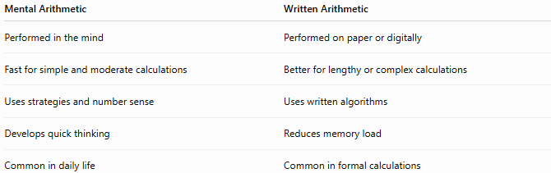
Mental Arithmetic | Written Arithmetic
Performed in the mind | Performed on paper or digitally
Fast for simple and moderate calculations | Better for lengthy or complex calculations
Uses strategies and number sense | Uses written algorithms
Develops quick thinking | Reduces memory load
Common in daily life | Common in formal calculations

Mental Arithmetic vs. Calculator
# Source: AI Source: Provided by: [Data Path: Persons Table -> ID Column: 1, Name_En Column: Motasem Essam] -> From: [ChatGPT] on [7/15/2026]
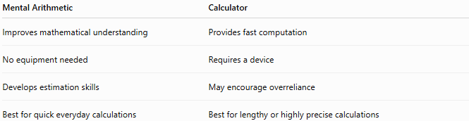
Mental Arithmetic | Calculator
Improves mathematical understanding | Provides fast computation
No equipment needed | Requires a device
Develops estimation skills | May encourage overreliance
Best for quick everyday calculations | Best for lengthy or highly precise calculations

Conclusion
# Source: AI Source: Provided by: [Data Path: Persons Table -> ID Column: 1, Name_En Column: Motasem Essam] -> From: [ChatGPT] on [7/15/2026]
Mental Arithmetic is the ability to perform mathematical calculations accurately and efficiently without written work or electronic devices. By using number sense, arithmetic properties, estimation, and calculation strategies, mental arithmetic enables quick problem-solving in everyday situations and provides a strong foundation for advanced mathematics, science, engineering, finance, and computer science. Regular practice improves both speed and confidence while strengthening overall mathematical thinking.

